Title of the Manuscript
(16pt; Bold; Capitalize each word)

Name of Author¹, Name of Author²
^{(12pts)}
¹Affilition (Department/division, Faculty, University, Country)
²Affilition (Department/division, Faculty, University, Country)
Corresponding author: email address
(10pts; Italic)

ABSTRACT

The abstract should be clear, concise and descriptive. It is written in 12 pt Times New Roman (single spacing) and preferably not more than 300 words. Abstract consists of:

Background: brief background of the topic and significance of the study.
Purpose: the primary aim of the research.
Methods: a summary of the study setting and participants; the study design; main methods used to collect and analyze data, including the proper name of instruments used.
Results: significant findings.
Conclusion: conclusions and implications for nursing practice.

Keywords:
Maximum of 5 keywords separated by a semicolon (;), crucial to the appropriate indexing of the papers, are to be given.

(Manuscript is written in 12 pt Times New Roman and single spacing.)

BACKGROUND
The background provides the state of the art of the study. It also consists of adequate references, the previous researches and significance of the study to show the scientific merit or novelties of the paper. Avoid the use of a literature review or a summary of the results.

OBJECTIVE
The objective of the research states the principal aim of the study.

METHODS
The method consists of research design, place and time of research, population and samples, data measurement, and data analysis methods. Please provide sufficient details of the methods include ethical conduct.

RESULTS
Results describe the significant findings of the study. It should be clear, concise and can be in the form of texts or graphics. Please provide some introduction for the information presented on tables or images.

DISCUSSION
The discussion should explore the significance of the results of the study. Following are the components in the discussion; how do your results relate to the original question or objectives outlined in the background section (what)? Do you provide interpretation scientifically for each of your findings presented (why)? Are your results consistent with what other investigators have reported (what else)? Or are there any differences?

CONCLUSION
The conclusion should answer the objectives of the study. Provide a clear scientific justification for your research, and indicate possible current and future practice recommendations.

ACKNOWLEDGMENTS (if any):
Briefly acknowledge the research funders and any research participants in this section.

REFERENCES
Write reference in APA format. The reference consists of all references used in writing the article. Ensure that citations used are as contemporary as possible, including those from the current year of writing. Delete older literature citations (more than ten years) unless they are central to your study. References should avoid the use of secondary sources. Please use Reference Manager Applications like EndNote, Mendeley, Zotero, etc.

FIGURE CAPTIONS
Figure 1. A sample chart/figure

TABLE CAPTIONS
Table 1. Formatting Rules
Table 1. Formatting rules
Object | Font | Alignment | Space above | Space below
Title | 12pt bold | centered | 0pt | 12pt
Author(s) | 12pt bold | centered | 12pt | 12pt
Affiliation | 12pt italics | centered | 0pt | 0pt
Heading1 | 12pt bold | left | 12pt | 3pt
Heading2 | 12pt bold | left | 6pt | 3pt
Heading3 | 12pt bold italics | left | 3pt | 3pt
Body | 12pt | justified | 0pt | 0pt
Bullet | 12pt | justified | 0pt | 0pt
Table title | 12pt | centered | 12pt | 6pt
Figure title | 12pt | centered | 3pt | 6pt

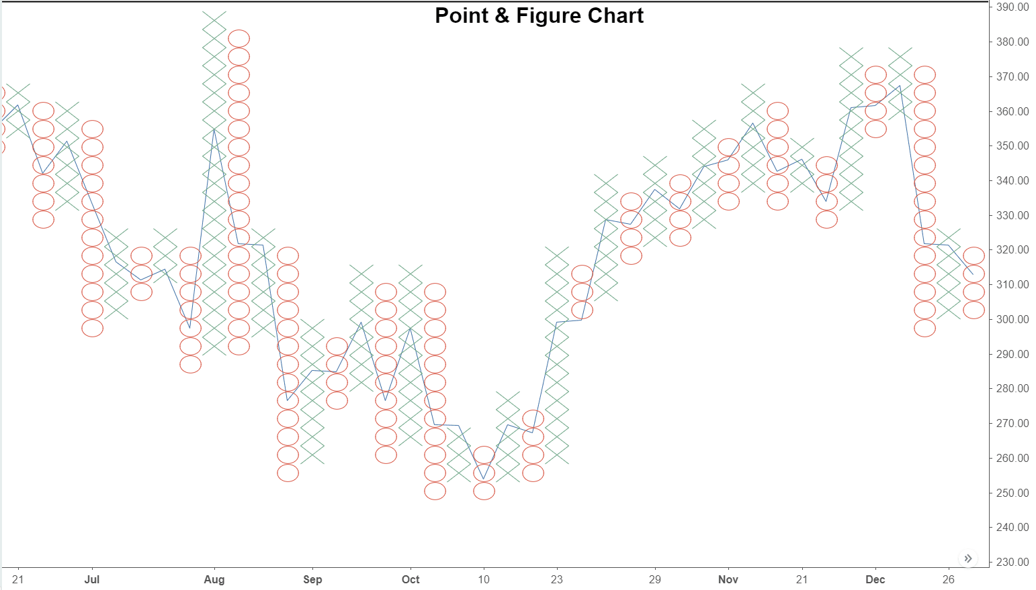

Figure 1. A sample chart/figure

